Brittany Stezskal
Megann Wenger
Tracy Ellingson
Kristy Kleinhans
Room Arrangement Reflection
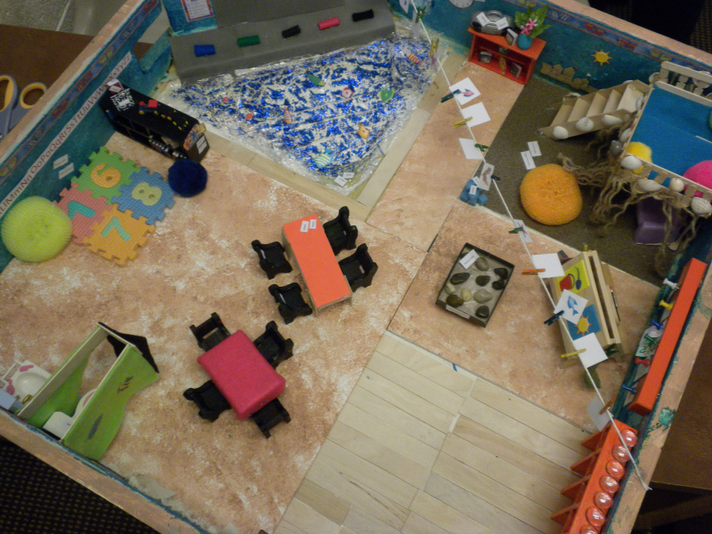

This was a fun and entertaining project that consisted of working in groups. This project really showed that working together is a huge part of working in the real world once we become teachers. We are going to constantly be talking to our fellow teachers and colleagues about ideas, and this project was just a start. We believe that without being a group it would make things ten times harder than they already were.
We believe that a great room arrangement contains many different elements and aspects. First off in every classroom there is always an alphabet and a number line that is circling the room. A classroom would not be complete without these items. Students who are struggling can use these items as a tool, and can look at for a reference. Another important aspect of a classroom is the media that is involved. Since the beginning of times teachers have been using books as the perfect learning tool, but we all know that this has changed over the years. In our era there are not only textbooks, but also computers with internet, which contains unlimited information. In our room arrangement we decided to place computers, a smart board, books, and even a stereo. These items are a great way to engage the students learning. Teachers today are always saying that teaching will become easier because of the fact that there are computers and they are starting to shy away from traditional books, but moving towards kindles, I Pods, even phones. To go along with the technology advances, there are those students who still use the books as a reference rather than going on the computer. When it comes to accessibility to students there is an unlimited amount of books in the classroom, the smart board is always on, and the computers are always running. Not every student is going to learn the same as the one sitting next to him or her, so it is a good idea to have to all these options available.
We have different sections in our room designated for different group and individual activities such as the reading area for small groups and the water rug in front of the smart board for class circle time. The tables could also be used for small or individual group activities. The art area is a small quiet area where only a few students can work at a time. The arrangement allows for easy access from one section to another as there is adequate space in between sections. Different sections in our room allow students to have their own personal space when desired. This may prevent confrontations between students. Our sections also allow for the teacher to redirect students if there are confrontations in the classroom. The reading area is furnished with cushions and has a relaxing environment which helps the students understand that the area is meant to be a quiet zone.
Our room sends a message that families are welcome in the classroom at any time. The entrance is an open area for many parents to come in and out as they are picking up and dropping off their children. It is also away from other centers which makes it less distracting to students if they are engaged in activities. The welcome area is also open enough and away from child centered activity areas so that children are not disrupting the process of parents coming in and out of the classroom with their children. This also allows space for the teacher and parents to communicate about the student and their progress.
The selected centers and their materials enhance learning and development in that it is visually appealing which encourages curious learners, active engagement, creativity and exploration in and through the environment. These characteristics alone contribute to and enhance child learning and development. The theme alone, for example, encourages students to be creative in their dramatic and free play, in learning activities and to self-explore their environment. Our model accommodates exceptional children by being a very flexible learning environment. If a child requires instruction that is different from the rest of the children, there are areas in the room for the child to work at a different pace. Our room can also accommodate children with physical exceptionalities. Our room has space for movement activities for a child who may need the extra space for moving. Our room also has adequate space in between centers for wheel chair accessibility if a child with this type of exceptionality is in the classroom.
Our model has also provided for flexibility in that many if not all of our spaces can be moved or have multiple uses. For example, our loft can be used as our dramatic play area or may be used as an area for quiet reading time. Our tables, sensory table and art easel may all be moved to different areas within the room. Our water rug area in front of the Smart board may be used for cooperative group learning activities such as early literacy activities, calendar time and morning message. Our water rug area may also be used for story and song time or may be an area for individual students to play quietly.
Our room arrangement displays a warm, safe and inviting environment through the use of our beach theme. We went with the beach theme because the beach can be a fun and relaxing place for all ages. We thought the color blue would go well with our theme to represent the water on a beach. We also decided that a beach theme with the color blue would be good because blue is a gender friendly and appropriate color. The materials in our room make it warm, safe and inviting; there are cushions, for example, in the relaxing areas to make it cozy and comfortable. There are also tables available for open, organized and structured activities which may be appealing to other students. The loft is appealing and inviting to children for independent or group activities in that they can climb and play on it. The organization of the space makes it inviting because each of the areas is designated by its own flooring.
Working on this project has been a very educating and rewarding experience. Working on this project gave us the opportunity to collaborate with each other as prospective educators. Though this project we have learned that collaboration is important and beneficial to teachers, students and the classrooms. Collaboration in this case, helped each of us bring our ideas for our room come together. Our collaboration in this case would also be beneficial to the classroom and students in that we have created a fun, warm, safe and inviting learning environment for students. We could not have finished this project without one of our collaborating partners as this was definitely a group effort. This project also gave us a good look into what a quality pre-kindergarten classroom should consist of by considering all the aspects of children’s development and deciding what is appropriate for them in their learning environments.

